

**Horizon 2020 Marie Skłodowska-Curie**

**Research and Innovation Staff Exchange Evaluations (RISE)**



**A CybEr range tRaining platform for medicAl organisations and systems Security**

**D6.1: Dissemination and Communication Plan** [[1]](#footnote-1)†

**Abstract**: The purpose of this deliverable is to present the Communication and Dissemination strategy that will guide the development of activities envisaged for the whole project, to maximize the impact of the project on target audiences, and to present the KPIs defined for the project which will allow to monitor and evaluate the success of the work performed in T6.1.

|  |  |
| --- | --- |
| Contractual Date of Delivery | 31/05/2022 |
| Actual Date of Delivery | 31/05/2022 |
| Deliverable Security Class | Public |
| Editor | *Jihane Najar (AEGIS), Georgiana Darau (AEGIS)* |
| Contributors |  |
| Quality Assurance | *ALL* |

The *AERAS* Consortium

|  |  |  |
| --- | --- | --- |
| Universita degli Studi di Milano | UMIL | Italy |
| Technical University of Crete | TSI | Greece |
| Technologiko Panepistimio Kyprou | CUT | Cyprus |
| Sphynx Analytics | STS-Cy | Cyprus |
| AEGIS IT Research UG | AEGIS | Germany |
| Panepistimiako Geniko Nosokomeio Irakleiou | PAGNI | Greece |
| Panepistimio Patron | UPAT | Greece |

*Document Revisions & Quality Assurance*

**Internal Reviewers**

1. *ALL*

**Revisions**

|  |  |  |  |
| --- | --- | --- | --- |
| **Version** | **Date** | **By** | **Overview** |
| 0.1 | 27/05/2022 | Jihane Najar | First Draft |
| 0.2 | 14/06/2022 | Jihane Najar, Georgiana Darau | Addressing review comments |
| 0.3 | 21/06/2022 | Jihane Najar | Updated version |
| 0.4 | 23/06/2022 | Jihane Najar | Final Version |
|  |  |  |  |

*Table of Contents*

[**1.** **Introduction** 8](#_Toc106984071)

[**1.1** **Purpose and objectives** 8](#_Toc106984072)

[**1.2** **Structure of the document** 9](#_Toc106984073)

[**2.** **Communication and Dissemination Strategy** 10](#_Toc106984074)

[**2.1** **Dissemination Principles** 10](#_Toc106984075)

[**2.2** **Communication and Dissemination Key Audiences** 10](#_Toc106984076)

[**2.3** **Difference between Dissemination and communication** 10](#_Toc106984077)

[**2.4** **AERAS’s dissemination and communication plan** 11](#_Toc106984078)

[**2.4.1** **Purpose of dissemination and communication plan** 11](#_Toc106984079)

[**2.4.2** **Contribution to open access Initiative** 11](#_Toc106984080)

[**2.4.3** **Internal Communication** 12](#_Toc106984081)

[**3.** **Communication and Dissemination Activities** 13](#_Toc106984082)

[**3.1** **Planned Dissemination and communication activities** 14](#_Toc106984083)

[**3.1.2** **Events and networking** 15](#_Toc106984084)

[**4.** **Communication and Dissemination Toolkit** 17](#_Toc106984085)

[**4.1** **AERAS Visual Identity** 17](#_Toc106984086)

[**4.1.1** **Logo** 17](#_Toc106984087)

[**4.1.2** **Document Layout** 17](#_Toc106984088)

[**4.1.3** **The funding information** 18](#_Toc106984089)

[**4.2** **Communication tools** 19](#_Toc106984090)

[**4.2.1** **AERAS Website** 19](#_Toc106984091)

[**4.2.2** **Social Media** 20](#_Toc106984092)

[**5.** **Monitoring – KPI’s** 24](#_Toc106984093)

[**6.** **Conclusion** 27](#_Toc106984094)

*List of Figures*

[Figure 2‑1 The boundaries of exploitation, dissemination and communication 11](#_Toc106984118)

[Figure 4‑1 AERAS LOGO 17](#_Toc106984119)

[Figure 4‑2 Presentation template 18](#_Toc106984120)

[Figure 4‑3 Information regarding funding source and Grant Agreement number included in all documents of the project 19](#_Toc106984121)

[Figure 4‑4 Website architecture 19](#_Toc106984122)

[Figure 4‑5 A screenshot of AERAS project website 20](#_Toc106984123)

[Figure 4‑6 AERAS Twitter account screenshot 21](#_Toc106984124)

[Figure 4‑7 AERAS LinkedIn account screenshot 22](#_Toc106984125)

[Figure 4‑8 AERAS Facebook account screenshot 23](#_Toc106984126)

*List of Tables*

[Table 3‑1 AERAS Target Groups 13](#_Toc106984127)

[Table 3‑2 AERAS' indicative targeted conferences 15](#_Toc106984128)

[Table 3‑3 AERAS' indicative targeted Events 16](#_Toc106984129)

[Table 4‑1 Social Media Accounts 21](#_Toc106984130)

[Table 5‑1 AERAS Dissemination and Communication KPIs 24](#_Toc106984131)

[Table 5‑2 AERAS Dissemination and Communication Expected Impact of Measures 25](#_Toc106984132)

*List of acronyms*

|  |  |
| --- | --- |
| Abbreviation | Definition |
| EC | European Commission |
| EHRs | E-health records |
| EU | European Union |
| Healthcare CTOs | Healthcare Chief Technology Officers |
| KPI | Key Performance Indicators |
| PHI | Personal health information |
| WP | Work Package |

# **Introduction**

Over the past years, the healthcare system has undergone dramatic changes due to the digital advancements which help with the improvement of the overall patient experience and outcomes. However, as the technology use in healthcare grows, so do the cyber-attacks. Therefore, there is a need to improve the system security in the healthcare domain because:

* Healthcare capitalizes on digital advancement to improve overall patient experience and outcomes by adopting e-health records (EHRs), increase the use of medical applications, use of online patient portals, use of connected devices and wearables
* There are high risks for the personal information to be used for fraudulent purposes or for the medical devices (e.g. smart wearable devices or implants) that can affect directly the health of patients
* The Personal health information (PHI) and EHRs that are stored in the healthcare organisations are of incredible value to cybercriminals which can be sold for profit on the black market
* The healthcare industry is the most targeted by ransomware due to the importance of sensitive data they have in their systems, however it is the lowest protected in terms of security
* Considerable data breaches were reported yearly by the HIPAA journal, such as successful hijacks of tele-operated surgical robots, or tampered drug infusion pups
* There are numerous and complex security vulnerabilities in the healthcare system because of systematic application of a common security policy but also from the failure of understanding the complex interaction between humans and the security systems
* There is a lack of cyber resilience and awareness among the personnel of the healthcare organisations due to the lack of appropriate training for developing and sustain an expertise for the prevention of cyber-threats and cyber attacks

Therefore, AERAS project aims at developing a realistic and rapidly adjustable cyber range platform for systems and organisations in the critical healthcare sector that:

* Will effectively prepare stakeholders with different types of responsibility and levels of expertise in defending high-risk, critical cyber-systems and organizations against advanced, known and new cyberattacks;
* Will help at reducing their security risks.

The platform will be a virtual cyberwarfare solution enabling the simulation of the operation and effects of security controls and offering hands-on training on their development, assessment, use and management.

The dissemination and communication plan serves as a, continually updating, manual for the dissemination activities during the lifetime of the AERAS project.

## **Purpose and objectives**

This deliverable is prepared in the context of Work Package 6 (WP6) “Dissemination and Communication Plan” which focuses on developing the dissemination and communication strategy of the project and identifying a set of actions and tools to raise awareness and engage relevant stakeholders.

The aim of the project’s communication activities is to call for attention from multiple audiences about the implementation of the research as well as addressing the public policy viewpoint of EU research and innovation financing. The idea is to share the research results with potential users such as peers in the research field, industry, other commercial players or policymakers, which will also contribute to the progress of science in general.

The purpose of this deliverable is to establish an inclusive and clear dissemination and communication plan. The present document describes a set of actions to be carried out within the AERAS project and the following topics will be addressed:

* The strategy for the communication and dissemination activities
* The key stakeholders to be targeted
* The channels and tools identified
* The planned activities
* The Key Performance Indicators (KPI) that will be used

Apart from the dissemination plan and in order to have a homogeneous strategy and approach to execute and report dissemination activities, the deliverable includes key dissemination materials and templates that will be available to be used by consortium partners.

## **Structure of the document**

The present deliverable is structured as follows:

* Section 1 introduces the AERAS project, gives an overview of the deliverable and its objectives.
* Section 2 presents the dissemination and communication strategy of the project.
* Section 3 presents the planned communication and dissemination activities.
* Section 4 describes the channels and toolkit used (e.g. visual identity, website etc.)
* Section 5 describes the KPIs established for the whole project.

# **Communication and Dissemination Strategy**

## **Dissemination Principles**

The development of the dissemination activities must follow the status of the project and its progress. In order to have an effective dissemination, all the activities should follow a number of principles such as:

* To duly protect confidential results.
* To coordinate actions between partners in order to avoid duplication or overlapping of dissemination activities.
* The project visual identity should be included where appropriate.
* The information should be available, accessible, adaptable and diversified.
* The information should be relevant and compatible to the different user groups so as to reach its maximum understanding and impact.
* The interaction with the end user must be stressed in order to create links between the project goals and the actual achievement.

## **Communication and Dissemination Key Audiences**

AERAS targets different types of stakeholders for disseminating project outcomes. The key target audience represents the backbone of the communication and dissemination strategy and has been clustered in the following categories:

* Healthcare CTOs (Chief Technology Officer).
* Cyber system providers.
* Educators and trainers.
* The scientific and research community.

It also includes other stakeholders, who may have an indirect interest in the AERAS outcomes such as:

* Cyber system user groups.
* Policy makers.
* The general public.

## **Difference between Dissemination and communication**

Although at first glance these two concepts seem identical, they are not. The dissemination concerns the transfer of information between those directly or indirectly involved in the work of parties, including the broader scientific community that is interested in state-of-the-art approaches to existing challenges, as well as new issues that will emerge from AERAS work. Communication is more about presenting the result or parts of it to end users, the media and third parties of legal or similar interest. The figure 2-1 below reflects the above statement by making a clear distinction between exploitation level, dissemination level and communication level.

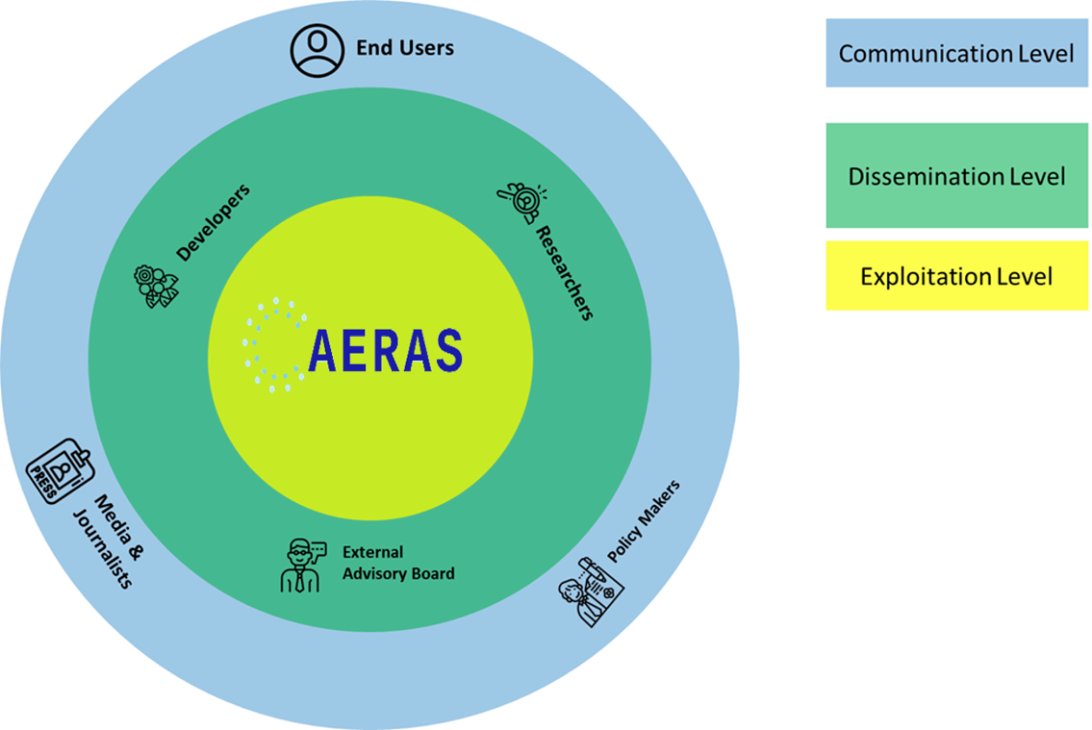

Figure 2‑1 The boundaries of exploitation, dissemination and communication

## **AERAS’s dissemination and communication plan**

The dissemination and communication strategy will be implemented following different channels in order to best target the desired stakeholder groups that will be most interested to the project’s results.

### **Purpose of dissemination and communication plan**

First of all, it is essential to define the purpose of the dissemination and communication in order to determine the targeted audience, the message, the methods and the timing of the dissemination. Therefore, the main goals of the dissemination are:

* To spread projects’ results;
* To contribute to the implementation of better security protocols and management for the healthcare system.

The purpose of the Dissemination Plan for AERAS would be to share projects progression results with stakeholder by organising specific events such as workshops and by submitting scientific papers to well established journals of health sector.

In addition to the dissemination of the project results it is important to use communication as a broader concept. By sharing information and promoting activities in relation or about the project, it contributes to raising awareness and enhance the visibility of the projects’ activities.

The purpose of communication plan for AERAS involves creation of printed and digital material that can be share with the broader audience and raise awareness within the health sector community.

### **Contribution to open access Initiative**

In addition to the dissemination measures presented above, AERAS project will provide Open Access to all of its results. In more detail, all project’s technical deliverables and respective scientific publications will be granted open access per publisher and law regulations as set out in the Grant Agreement.

Depending on the nature of the publication, the articles will be made available immediately through open access publishing ('gold' open access) (e.g. by an open access journal) or within a period of 6 months through self-archiving ('green' open access).

Some AERAS partners have already established various Open Access policies (https://air.unimi.it/) supporting authors in retaining their rights to provide access to published articles, providing official repositories and making the bibliographic metadata that identify the deposited publication available to OpenAIRE (openaire.eu). Other means include finding suitable repositories via OpenAIRE, the Registry of Open Access Repositories and the Directory of Open Access Repositories.

Thus, the Consortium will fully address the European Commission requirements and will enable the use and uptake of results when available through the support of open access.

### **Internal Communication**

Besides the external dissemination activities, internal dissemination activities and communication are essential for accomplishing the purpose of the dissemination plan.

As such, there is a need to ensure continuous collective awareness of project goals and progress, collaboration, coordination and coherence among the project partners. In order to ensure this, certain activities should be accomplished by the project’s team:

* Presentations of work progress during periodic meetings (by WP leaders, and the partners involved.
* Sharing of documents thought a common platform (SharePoint).

# **Communication and Dissemination Activities**

As AERAS targets different types of stakeholders for disseminating project outcomes, these stakeholders include direct potential users of the project outcomes, **(a) healthcare CTOs**, **(b) cyber system providers**, **(c) educators and trainers** (who can embrace and develop further the cyber-range platform of the project), and (**d) the scientific and research community** (consumers of outcomes for research purposes). It also includes other stakeholders, who may have an indirect interest in the AERAS outcomes, like **(e) cyber system user groups, (f) policy makers** (primarily in Europe), and **(g) the general public**.

AERAS will use different communication channels in order to realize its dissemination strategy for the direct potential user groups.

Each dissemination activity needs to be tailored to the specific group according to the specific message to be conveyed. Therefore, the content for each category of targeted audience is as follows:

Table 3‑1 AERAS Target Groups

|  |  |  |
| --- | --- | --- |
| **Target Group** | **Aim of the Plan** | **Way of achievement** |
| **Healthcare CTOs** | The shared information aims to help healthcare CTOs and healthcare IT support staff in general, to better understand how to apply the AERAS’s approach and platform to their systems and assess the potential business benefits of it (e.g., reduced level of security risks, higher staff awareness of and preparation for cyber risks, reduced liability against cyber incidents). | The targeted audience will be informed mostly through organizing industrial events and networking events.  The information will also be share through the AERAS web site, social media, mailing lists, press releases, publications in conferences and journals, and publications in business and general press. |
| **Cyber System Providers** | The provided information aims to help cyber system providers understand how to apply the AERAS approach on security and security training and its platform and assess the potential business benefits of it (e.g., reduced risk and liability, increased trustworthiness, reduced complexity and improved user friendliness of their systems, etc.). | Industrial events and networking events will be organised by AERAS.  The information will be shared on all communication channels such as web site, social media, mailing lists, and published in press releases, in conferences and journals, and publications in business and normal press. |
| **Educators/Trainers** | The information aims to help communities understand how to apply the AERAS approach on security and security training and its platform and assess the technical and business implications of it. | AERAS will organize scientific and networking events in order to promote the project among the targeted audience.  Details about the project will be shared on different communication channels such as the AERAS web site, social media, mailing lists, or published in press releases, in conferences and journals.  AERAS will also be present in conferences and working groups where the project will be promoted. |
| **Scientific/Research Communities** | For this specific target audience the information aims to help the communities understand how to apply the AERAS approach and its platform and assess the technical and business implications of it. | Scientific events and networking event will be organised by AERAS.  Details about the project will be shared on different communication channels such as the AERAS web site, social media, mailing lists, or published in press releases, in conferences and journals.  AERAS will also be present in conferences and working groups where the project will be promoted. |

## **Planned Dissemination and communication activities**

The dissemination and communication strategy will be implemented following three different channels in order to best target the desired stakeholder groups that will be most interested to the project’s results. The dissemination and communication strategy to be implemented is explained in the following sub-sections.

1. **Journal Publications, Scientific Papers**

The development and publication of scientific papers in conferences, journals and magazines is a suitable approach to promote a project in the scientific and research community . It is important to attract the attention of interested parties.

AERAS intends to publish its findings in prestigious scientific journals and conferences. This will serve numerous purposes:

1. to raise the scientific and research communities' awareness of project outcomes;
2. seek scientific input through peer review;
3. establish the project's scientific validity and credibility.

The fora targeted for scientific publications should be top quality ones. This will not only best serve the goals (1)(3), but it will also increase the likelihood of substantial scientific acknowledgment and influence. An equally important objective will be to ensure open access to published project outcomes as widely as possible.

Therefore, AERAS consortium will seek to publish this kind of scientific content on several international refereed, scientific and technical journals and conferences in security. Table 3.2 lists some examples.

Table 3‑2 AERAS' indicative targeted conferences

|  |  |
| --- | --- |
| **Conferences** | **Link** |
| Digital Health World Congress | <https://digitalhealthcareworldcongress.com/> |
| 19th World congress on Healthcare and Technologies | <https://www.clocate.com/world-congress-on-healthcare-and-technologies/72651/> |
| HEALTHINF 2023 | <https://healthinf.scitevents.org/> |

### **Events and networking**

***Direct Interactive Dissemination***

Direct presence of AERAS partners to events such as industrial fairs, workshops and symposia, networking events and networking events in order to present the outcome of the project will offer a chance for personal interaction with external stakeholders. It is also effective in providing information that is tailored to different target groups. The direct interactive channel of dissemination is expected to be the most efficient channel for community building and developing awareness on project outcomes and eventually enabling exploitation. The direct interactive dissemination channel will also include participation of project partners in various working groups to promote discussion and obtain feedback about AERAS outcomes.

Therefore, the AERAS outcomes will be presented in:

1. industrial fairs, workshops and symposia;
2. networking events (e.g., events organised by the EU to coordinate projects in specific thematic, technology, and business areas);
3. scientific conferences, workshops and symposia.

***Organisation of industry and scientific events***

Research-focused workshops will be organised in conjunction with top tier international conferences in the core research areas of the project (e.g., cyber range systems, cyber security) so as to achieve a higher visibility of project outcomes. We will also seek to have presence in industry-focused workshops and major industry events (e.g., INFOSEC).

***Marie Skłodowska-Curie open research days or researchers’ nights***

Table 3‑3 AERAS' indicative targeted Events

|  |  |
| --- | --- |
| **Events** | **Link** |
| **IFIP HAISA 2023**, **17th IFIP International Symposium on Human Aspects of Information Security & Assurance** | <https://haisa.org/> |
| **SocialSec 2023** - **9th International Symposium on Security and Privacy in Social Networks and Big Data** | <https://socialsec2022.xidian.edu.cn/> |
| **Health-ISAC Europe Summit 2022** | - <https://h-isac.org/summits/2022-european-summit/> |

# **Communication and Dissemination Toolkit**

Within this section the different dissemination tools, templates and materials are described. It includes also key dissemination and communication events that will be targeted by AERAS members. All partners in all communications must consider the guidelines to ensure coherence and contribute to the positioning of AERAS among stakeholders.

This section gives an overview of the project’s visual identity. As an EC funded Research and Innovation project, a clear project brand identity needs to be implemented in order to have an impact with the dissemination of respective work and achievements. The branding of the project must be considered as a key element of the communication strategy as it reflects the core values and characteristics of the project. This visual identity is designed to make it a unique, recognizable brand and flexible enough to support all online and offline communications of the project across all communication channels and in all dissemination tasks.

The components of the “brand” of the AERAS project are:

* The logo
* The layout of the documents
* The language

## **AERAS Visual Identity**

## **Logo**

One of the first steps during the implementation of the project was to create a recognizable logo. It represents the main graphic identity element of the project and ensures that the project outputs are easily recognizable. It will be used and placed in all materials, activities and channels related to the project such as deliverables, website, technical documents, presentations or agendas.

The logo of AERAS project has been designed by the coordinator and approved by all partners. Different variations were prepared in order to select the most appropriate version.



Figure 4‑1 AERAS LOGO

## **Document Layout**

A homogenized structure of the documents of the AERAS project is important to make the communication process as efficient as possible. To ensure uniform presentations, templates for documents, deliverables, and slides including AERAS’ logo were prepared and have been made available to Consortium partners via the project’s internal repository.

The template for a presentation is presented below:

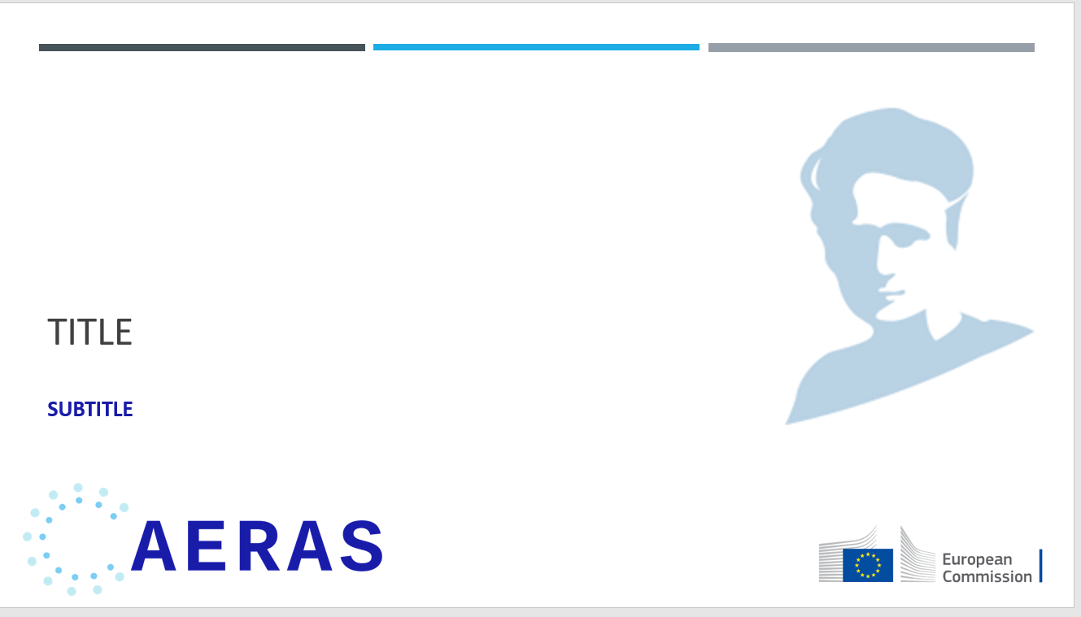

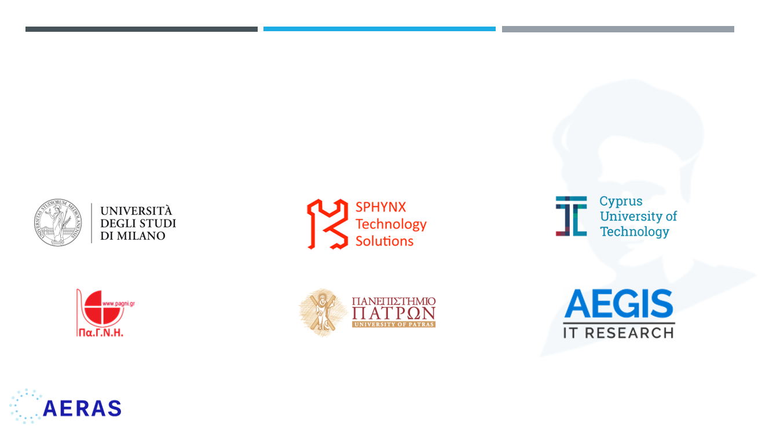

Figure 4‑2 Presentation template

Based on the needs of the project, additional templates can be similarly created and stored in the relevant space of the SharePoint platform of the project.

### **The funding information**

All activities should contribute to the visibility of European funds among citizens.

In compliance to European Commission (EC) guidelines, all dissemination materials related to the project and any infrastructure, equipment and major results funded by the grant must display the EU emblem as reproduced in Figure 4-3 and also must include the text “This project has received funding from the European Union’s Horizon 2020 research and innovation programme under grant agreement No 872735”



Figure 4‑3 Information regarding funding source and Grant Agreement number included in all documents of the project

## **Communication tools**

### **AERAS Website**

Online presence will give the project vast exposure on the web, the AERAS website presents the main communication tool for the project as it has the capability to address a wide range of stakeholders who can easily access the information they are interested in. A user-friendly, well-designed and easily accessible website where all the dissemination materials will be published in a timely manner and will be updated throughout the whole project. It contains most of the important information about the project such as the project scope, its goals, information about all the consortium members, project deliverables, activities and achieved results etc.

**AERAS Website Map:**

Figure 4‑4 Website architecture

The main pages of the Website are:

* **Home**: represents the welcome page and contain the project statement and an overview of the consortium. It also features the icons and links to the project social media accounts such as Twitter, Facebook and LinkedΙn. Finally, the footer includes the disclaimer of the EC that contains the Grand Agreement number;
* **The project**: It presents and provides a description of the project and other relevant information such as a list and description of the WPs;
* **News & Events**: Provides information on events and meetings that have taken place.
* **Resources**: It contains a list of the deliverables of the project that based on their classification level are allowed to be publicly available. This page also contains the publication of articles and white papers;
* **Contact**: Provides information and contact details about the project coordinators.

All AERAS partners will have the chance to contribute to its update by providing information about the project progress, related news, and events in their field of expertise.

The website is available in English at <https://www.aeras-project.eu/>

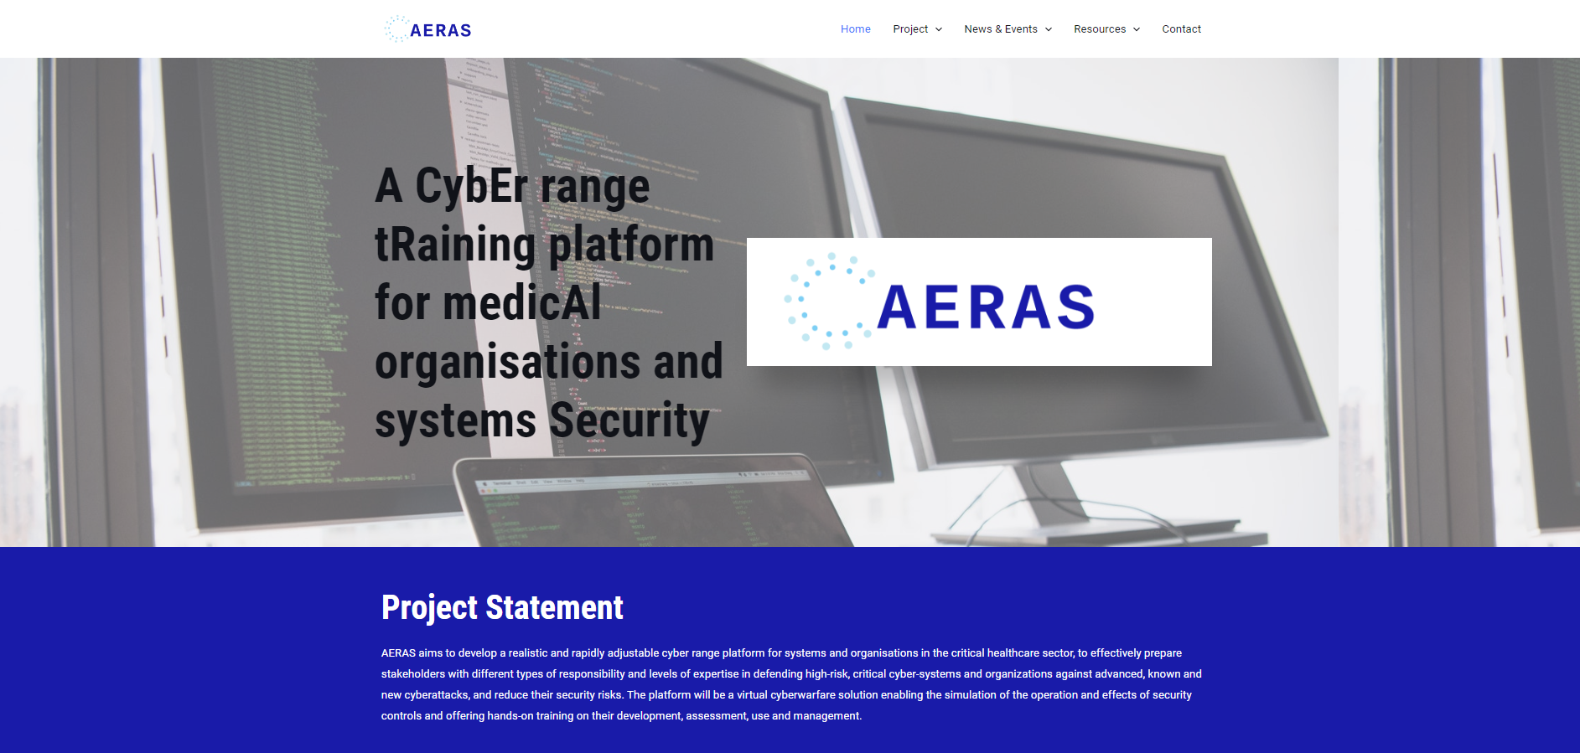

Figure 4‑5 A screenshot of AERAS project website

### **Social Media**

One of the most common tools used to engage a wide audience is through the use of social media networks. AERAS project uses several social media platforms to build its online community and help to raise awareness and recognition of the project as well as to disseminate information as widely as possible. Each social media platform has different audiences.

AERAS is active on three social media networks:

Table 4‑1 Social Media Accounts

|  |  |  |
| --- | --- | --- |
| SOCIAL MEDIA ACCOUNTS | | |
|  | **@EuAeras** | <https://twitter.com/EuAeras> |
| C:\Users\jihen\Desktop\LinkedIn_icon_circle.svg.png | **AERAS EU – H2020** | <https://www.linkedin.com/company/aeras-eu/about/> |
|  | **AERAS EU – H2020** | <https://www.facebook.com/aeras.eu.H2020> |

**Twitter**

AERAS **Twitter** account has been created andwill be used to communicate quick updates and short messages. Retweeting by individuals and partners is encouraged and will increase the visibility of **@EuAeras.**

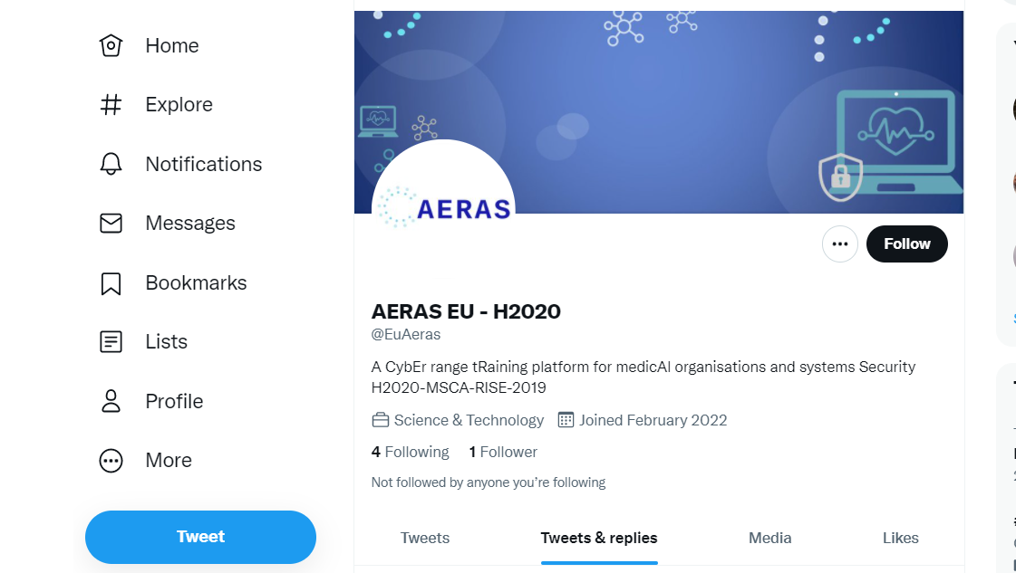

Figure 4‑6 AERAS Twitter account screenshot

**LinkedIn**

**LinkedIn** profile is a more profession-based social media platform where in general members have a chance to showcase their professional accomplishments. AERAS LinkedIn account will be very important for opening business opportunities for the project’s results.

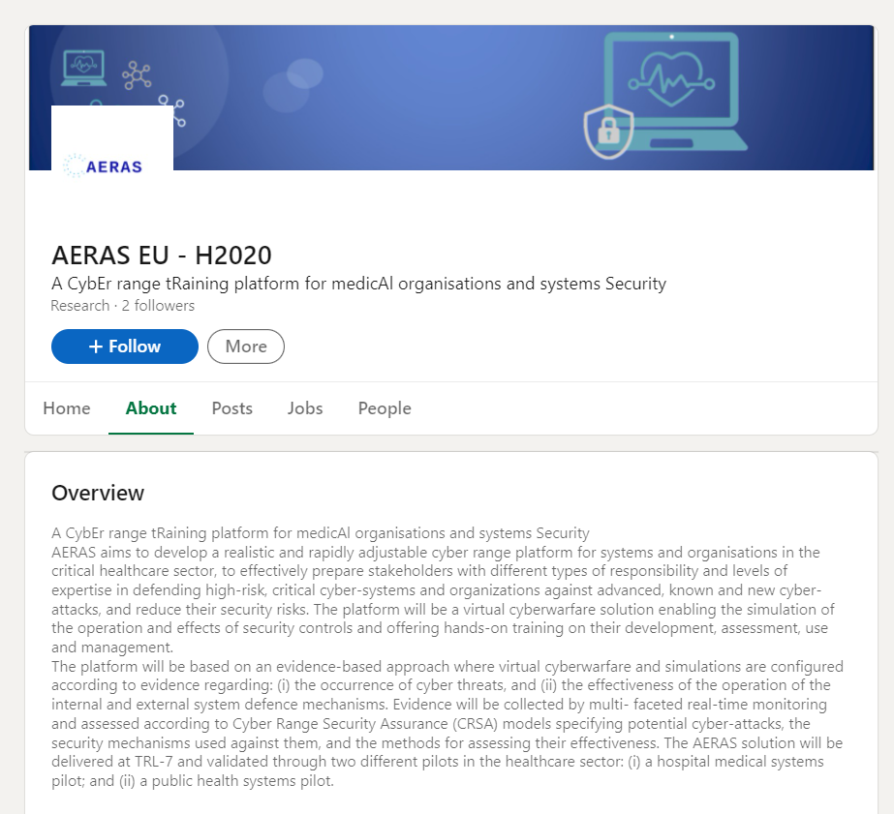

Figure 4‑7 AERAS LinkedIn account screenshot

**Facebook**

**Facebook page** will be used to attract a broad audience.

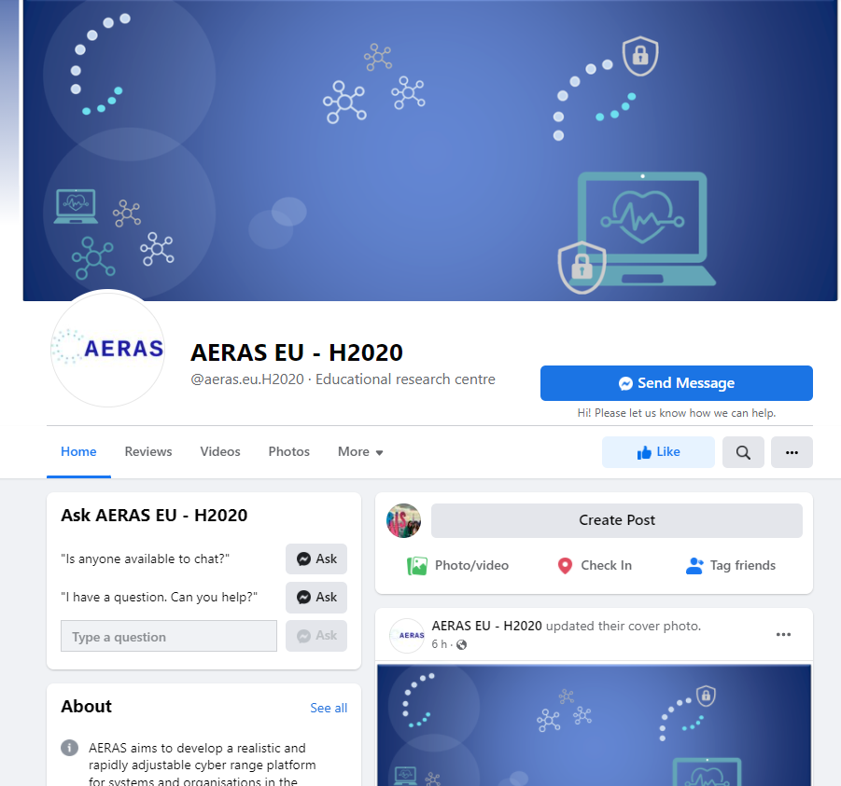

Figure 4‑8 AERAS Facebook account screenshot

These social media channels will be used to provide an instant form of the flow of news and content added continuously. Through frequent posts and interaction, the project will ensure continual visibility of its efforts. The project’s social media channels will be also supported by all partners.

In general, all social media accounts will have common objectives as follows:

* Share relevant information/news on AERAS.
* Promote relevant events and inform audiences about AERAS participation
* Share pictures/images when possible or appropriate related to AERAS.
* Can act as a multiplier for information/news (from other relevant projects/accounts).

The project’s social media presence will play an important role in the development of the AERAS community. Therefore, to maximize the spread of its awareness and its impact, all partners should support AERAS social media channels by their own social media and ensure that the project has active social media engagement.

# **Monitoring – KPI’s**

For the dissemination and communication activities, it’s important to have tools to effectively monitor and assess the success of the plan. The evaluation of the dissemination and communication activities will determine if the plan objectives have been reached. Thus, a set of KPIs has been defined for the total duration of the project in order to cover all the aspect of the dissemination and communication.

KPIs cover website and social media statistics, event participation and quantity of publications. The following table reports the main communication and dissemination activities. The values presented in this table state the threshold set for each KPI by the consortium and exceeding these values will be an indication of excellent performance.

The KPIs will be subject to regular revision and thresholds will be updated based on the ongoing performance.

Table 5‑1 AERAS Dissemination and Communication KPIs

|  |  |  |  |
| --- | --- | --- | --- |
| **Tool** | **KPIs** | **Description** | **Coverage** |
| Project website;  technical section | ≥ 3.000 accesses  ≥100 downloads | Access to *AERAS* deliverables, technical results and presentations | Worldwide |
| Professional Social  Media | ≥50  announcements | Regular push announcements on professional social media (LinkedIn,  ResearchGate) | Worldwide |
| Regular Newsletter | ≥8 newsletters | Bi-annual newsletter with the technical activities of *AERAS* | Europe |
| Brochure | ≥2.000 hard copies  distribution in ≥ 10 events | High–quality electronic brochure with the technical approach and activities of *AERAS* | Europe |
| Journal and  Magazine  Publications | ≥5 publications;  ≥50 citations | International refereed technical journals and magazines in cyber security related subjects; e.g., ACM Transactions on Information and Systems Security, IEEE Transactions on Secure and Dependable computing, Computers and Security,  IEEE Security & Privacy Magazine | Europe |
| Conference &  Workshop  Publications | ≥10  ≥100 citations | International refereed technical journals and magazines in cyber security related subjects**:** ACM Conference on Computer and Communications Security, ACM  Conference on Computer and Communications Security; ACM Conference on Data and Application Security and Privacy. | Europe |
| Special Issues in Scientific Journals | ≥1  >50 citations | The partners will take the initiative of jointly creating at least one special issue in a scientific journal, and invite top international colleagues to be part of the initiatives. This creates a strong and long‐standing link between the partners and their scientific community | Europe |
| Workshop  Organisation | ≥2 workshops  ≥30 attendees  (each) | *AERAS* will organise two scientific workshops, to promote an interactive  dissemination of project outcomes to the relevant stakeholders. These workshops will be important not only to disseminate project outcomes but also to obtain the opinion of experts on the current achievements and discuss ways of improving and/or enhancing the *AERAS* framework. | Europe |
| Conference &  Exhibition demos | ≥2 demos | Demos in major Cyber Security related conferences or major fairs and exhibitions  (Cyber Security Europe at IP EXPO Europe, INFOSEC). | Europe |

Table 5‑2 AERAS Dissemination and Communication Expected Impact of Measures

|  |  |  |
| --- | --- | --- |
| **Planned Means** | **Success Indicators** | **Coverage** |
| Project Website, non-technical section | ≥ 3.000 accesses,  ≥ 100 downloads | Worldwide |
| Press echoes | >1 | Europe |
| Newspapers | >1 | Europe |
| Social Media | >300 followers | Worldwide |
| Public lectures and/or networking event for the general public | ≥ 2, >5 attendees (each) | Europe |
| Public lecture and/or networking event for policy makers | ≥ 2, >5 attendees (each) | Europe |
| Marie Sklodowska-Curie open research days or Researchers’ nights | ≥ 2, >5 attendees (each) | Europe |

# **Conclusion**

AERAS project aims at developing a realistic and rapidly adjustable cyber range platform for systems and organisations in the critical healthcare sector that will effectively prepare stakeholders with different types of responsibility and levels of expertise in defending high-risk, critical cyber-systems and organizations against advanced, known and new cyberattacks and it will help at reducing their security risks. The platform will be a virtual cyberwarfare solution enabling the simulation of the operation and effects of security controls and offering hands-on training on their development, assessment, use and management.

The main output of the Deliverable 6.1 is the AERAS dissemination and communication strategy and plan. This plan serves as a manual for the dissemination activities during the lifetime of the AERAS project.

This report proposes diversified channels (website, social media, publishing papers, participation in relevant events, etc.) of promoting the project throughout its lifetime with specific plans appropriate for the targeted stakeholders. Moreover, in order to measure the effectiveness of the dissemination and communication activities, key performance indicators have been defined and explained in Section 4 of this document.

Following the goals planned and the achievements of the dissemination and communication strategy of AERAS, the planned actions that will take place the following months are:

* Updating the website with content.
* Annual virtual or physical meetings with the Advisory Board.
* Organization of a series of events including Workshops.
* Collaboration with other EU projects and consortiums.

1. † *The research leading to these results has received funding from the European Union’s Horizon 2020 research and innovation programme under grant agreement No 872735.* [↑](#footnote-ref-1)