Meeting Venue & Local Information

The meeting will take place at the new building of the Computer Science Department of the Università degli Studi di Milano.

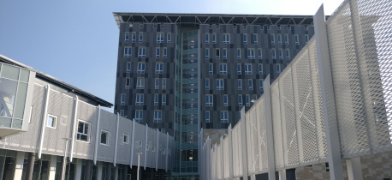

Location: Dipartimento di Informatica, via Celoria 18 – 20133 Milano (Italy)
Meeting Room: Sala Consiglio, 8th floor.

How to reach Milan
- By air: Milan is served by three International airport
  - Milano Malpensa: on the west of the city, well-connected by train and buses. To reach Milan you can take the Malpensa Express train or the Malpensa Shuttle bus. More information on the Malpensa Airport website.
  - Milano Linate: the city airport of Milan, very close to the city, but still not connected to the train line. To reach the city center you must take the bus number 73. For information about the bus connection please refer to the Milano Linate website.
  - Bergamo Orio al Serio: served mainly by Ryanair, it is connected to Milan by bus
- By train: Milano Centrale is one of the major train hub of Italy, connected to many European cities.

Getting around
Public transportation in Milan are very efficient and you can plan your travel easily using Google Maps. The metro line is composed by four trunks characterized by specific colors (Red, Green, Yellow, and Purple), covering the city center and the most important tourist and business attractions. For more information about public transportation, please refer to the ATM website.

Tickets (€ 2) can be purchased at ticketing machines in metro stop and in newsstands and tobacco shops that expose the ATM logo. Tickets last 90 minutes and it can be used for unlimited journeys on buses and trams and for one single journey on the metro, including all connections. Please note that you can use contactless credit card to pay metro rides directly on specific metro turnstiles.

Remember that the last ride of the Metro is at 1:00 AM. If needed there are night buses.

Please remember to keep your ticket, since you must validate it also exiting the metro (same if you used the credit card, you must pass it again on the reader).

How to reach the venue
The venue is within the Universities City Campus and can be reached by taking the Green Metro line until Piola stop, and then walk until the premises (directions). Otherwise, you can take the landline n. 19 that connect Piazza Duomo to Piazza Leonardo da Vinci (directions).

By Taxi:
Taxis can be expensive in Milan, however you can reserve one calling +39026969 or by app.

By Car:
The venue is easy reachable by car, but parking can be complex since the department is located in the campus and many students usually come by car.

Accommodation
All the city of Milan is well covered by public transportation, allowing visitors to select the hotel also far from the venue. Currently, the Department could not offer you discounted rates. We suggest you some options for specific areas.

Universities City Campus (Città Studi)

- Hotel Leonardo da Vinci *: rooms from € 55
- B&B Bronzino House: double rooms from € 80
- Hotel Gamma ***: rooms from € 70

City Center
More expensive but very closes to all touristic attractions and well served by public transportation. Rooms start from € 200. Booking.com

Place to visit
City Center: the central Piazza Duomo is dominated by the Duomo di Milano and from there you can easily reach the Castello Sforzesco through the Art District (directions)

Darsena: Milan is crossed by the Navigli, the channels once used as waterway. Now they are common place for pubs, cafes, restaurants, … (map)

Piazza Gae Aulenti: the new skyline of Milan… (map)
Milan Metro Map
