

**Horizon 2020 Marie Skłodowska-Curie**

**Research and Innovation Staff Exchange Evaluations (RISE)**



**A CybEr range tRaining platform for medicAl organisations and systems Security**

**D7.3:** POPD - Requirement No. 9[1]†

**Abstract**: This deliverable provides an evaluation of the ethics risks related to the data processing activities of the project, basing on the opinion if data protection impact assessment released by the Ethics Authority as requested by the Coordinator.

|  |  |
| --- | --- |
| Contractual Date of Delivery | 31/12/2020 |
| Actual Date of Delivery | 31/12/2020 |
| Deliverable Security Class | Public |
| Editor | *Ernesto Damiani, Fulvio Frati (UMIL)* |
| Contributors | All partners |
| Quality Assurance | *All Partners* |

The *AERAS* Consortium

|  |  |  |
| --- | --- | --- |
| Universita degli Studi di Milano | UMIL | Italy |
| Technologiko Panepistimio Kyprou | CUT | Cyprus |
| Sphynx Technology Solutions AG | STS | Switzerland |
| AEGIS IT Research UG | AEGIS | Germany |
| Panepistimiako Geniko Nosokomeio Irakleiou | PAGNI | Greece |
| Panepistimio Patron | UPAT | Greece |
| Telecommunication Systems Institute | TSI | Greece |

*Document Revisions & Quality Assurance*

**Internal Reviewers**

1. *All Partners*

**Revisions**

|  |  |  |  |
| --- | --- | --- | --- |
| **Version** | **Date** | **By** | **Overview** |
| 1.0 | 30/12/2020 | Editor | Final version |
| 0.2 | 15/12/2020 | Editor | Deliverable complete for review |
| 0.1 | 01/12/2020 | Editor | First Draft |

**Executive Summary**

This Deliverable describes the outcomes of the hearing requested by the AERAS Project Coordinator to the Università degli Studi di Milano’s internal Ethics Committee. This deliverable comes as an answer to the request of the EC “*The beneficiary must evaluate the ethics risks related to the data processing activities of the project. This includes also an opinion if data protection impact assessment should be conducted under art.35 General Data Protection Regulation 2016/679. The risk evaluation and the opinion must be submitted as a deliverable.*”

*Table of Contents*

**1.** **Introduction** 7

**2.** **Ethics Committee Opinion** 8

**1.1** **UMIL’s Ethics Committee** 8

**1.2** **AERAS Hearing to Ethics Committee** 8

**3.** **AERAS Protocol** 14

**4.** **Conclusion** 21

**5.** **References** 22

**Appendix A: Official Committee opinion request** 23

**Appendix B: Ethical form** 25

**Appendix C: Project Responsible conflict of interest absence form** 28

**Appendix D: Excerpt of the Computer Science Dep. Council meeting** 29

*List of Figures*

Figure 1: Excerpt of the Ethics Committee meeting related to the AERAS Hearing. 12

Figure 2: Ethics Committee opinion. 13

# **Introduction**

This deliverable comes as an answer to the request of the EC “*The beneficiary must evaluate the ethics risks related to the data processing activities of the project. This includes also an opinion if data protection impact assessment should be conducted under art.35 General Data Protection Regulation 2016/679. The risk evaluation and the opinion must be submitted as a deliverable.*”

In AERAS, the Consortium has put forth its determination to carefully process the possible ethics issues related with the human participation in the various research activities that will be conducted. These mainly involves training sessions (i.e. selection of trainers and trainees) and other stakeholders who could test and evaluate the provided platform.

Research activities are not expected to collect specific personal data associated to the humans participating in the evaluation activities, but only data related to the usage of the platform itself with anonymized or pseudo-random data. Furthermore, the test will be conducted in the pilots premises and administered by personnel belonging to the pilots themselves.

As mentioned in Section 5 of the Grant Agreement (GA), rules and principles will be strictly upheld, particularly including the Charter of Fundamental Rights of the European Union. Compliance with the Convention of the Council of Europe for the protection of individuals with regard to automatic processing of personal data and the General Data Protection Regulation (EU) 2016/679, is covered in a different deliverable (D7.2) as the overall procedures lay in the context of a distinct ethics type for personal data.

In particular, D7.2 includes the templates of the *Participant Information Sheet* and the *Informed Consent Form* that will be used by the project beneficiaries.

Furthermore, this deliverable aims at confirming that the AERAS Consortium is fully aware of the privacy risk due to the management of data about human performance in the evaluation process. To be prepared to them, the Coordinator has requested an opinion to the Ethics Committee of the Università degli Studi di Milano. Such an opinion is provided in Section 2 in Italian and in English. Furthermore, in the Appendixes, the requested documentation package is provided as it was presented during the Ethics Committee hearing.

# **Ethics Committee Opinion**

The Coordinator, as requested also by the Università degli Studi di Milano internal regulations, has presented the AERAS project to the University’s internal Ethics Committee. In the following section, we provide a short introduction of the scope and responsibilities of the Committee, and the results of the hearing. In the Appendix, the set of documentation sent to be included in the Committee meeting is presented.



## **UMIL’s Ethics Committee**

The Ethics Committee of UMIL has been appointed in 2006. It expresses an opinion on studies submitted by researchers working at the University for the purposes of:

* protecting the rights, dignity, integrity and well-being of the human beings involved;
* ensuring environmental stewardship, protection and conservation;
* promoting and ensuring compliance with Research Integrity.

Its opinion is normally required when research projects to national, EU or international institutions are accepted for funding, and in case publication of sensitive data from research activities in scientific journals.

However, the Ethics Committee does not have competence on clinical trials of drugs pursuant to Article 3 of the Ethics Committee Regulation [1], stating that “*the functions reserved by law to the ethics committees of other institutions, namely hospitals, are outside the province of the University Ethics Committee*".

The Ethics Committee activities and responsibility are defined in the “Code of Ethics and for Research Integrity” [1]. The Code set out the ethical principles that apply to all University personnel and students, and to all areas of research. These principles are taken as standards of behavior upheld by the University and shared by the international research community. However, they shall be considered guidelines that in no way substitute the more specific rules of conduct and standards in individual subject areas. In particular, interpretation and application of the Code shall take into account the more important international documents concerning research integrity, the European policy of Responsible Research and Innovation (RRI), the European Charter of Researchers, as well as any relevant conventions and agreements undertaken by the University.

The Committee is appointed every three academic years, and includes internal scientific experts and one external member, specialized in different fields, such as Law, Medicine, Veterinary, Philosophy, Religious Studies. The Data Protection Officer of the University is also part of the Committee.

## **AERAS Hearing to Ethics Committee**

The Coordinator requested to be heard at the Committee in April 2019. In order to be accepted, the following documentation has been provided to the Committee Secretary:

* Official Committee opinion request (Appendix A), containing an high level description of the project;
* Ethical form (Appendix B), that contains an high level description of the ethical implication of the project, as described in the proposal phase.
* Project ethical protocol (see Section 3), that describes in detail the ethical risks overseen for the project (if any) and the Partners’ involvement.
* Short description of the project in Italian and in English.
* Information Sheets and Informative Consent Form, already presented in D7.2.
* Coordinator’s conflict of interest absence form (Appendix C).
* Excerpt of the Department of Informatics Council meeting, confirming the participation of the Department to the project (Appendix D). This document also includes the declaration of the Coordinator to request the opinion to the Ethics Committee.
* Curriculum vitae of the Coordinator (Prof. Ernesto Damiani), available online[2].

The Committee met virtually the 14 of May, 2020, where Prof. Damiani introduced the project and presented the research activities and the possible Ethics risks it could involve. The Committee raised concerns in particular related on specific sentences of the Information Sheet and Consent Form, as described on Page 2 of the document in Figure 1. The text in Italian reports the following:

*The concerns of the Committee are the following:*

* *In the Information Sheet it should be better specified that collected data will be used for aggregated measures, targeted to a collective improvement of the group rather that the single participant.*
* *Also for this project, with respect to the data storage, the participant should be clearly informed that, if the collected data is anonymized, there could be no time limitation for its storage, since there is no direct link with the participant.*

Concluding, Figure 2 reports the Committee favorable opinion in English.

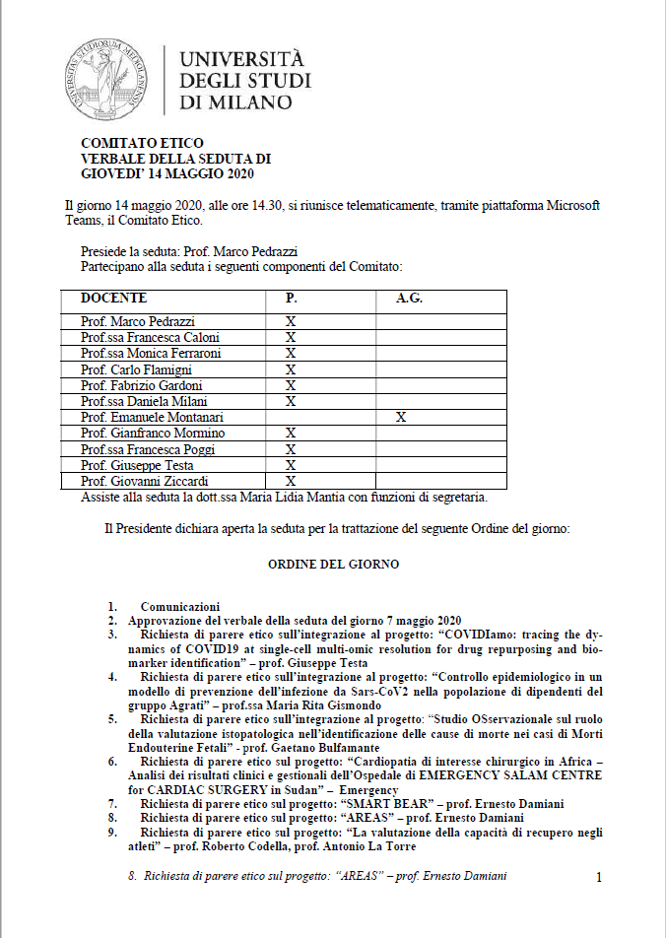

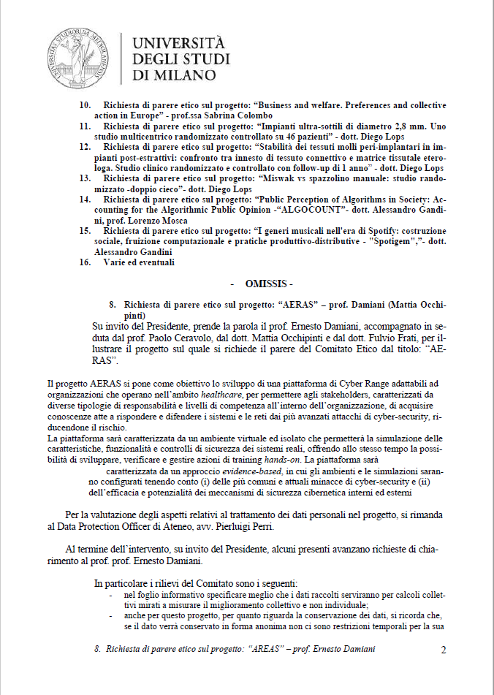

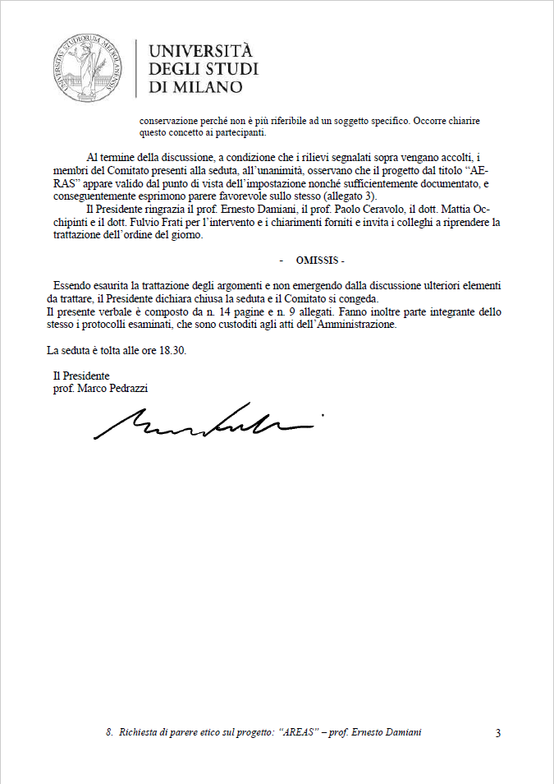

Figure 1: Excerpt of the Ethics Committee meeting related to the AERAS Hearing.

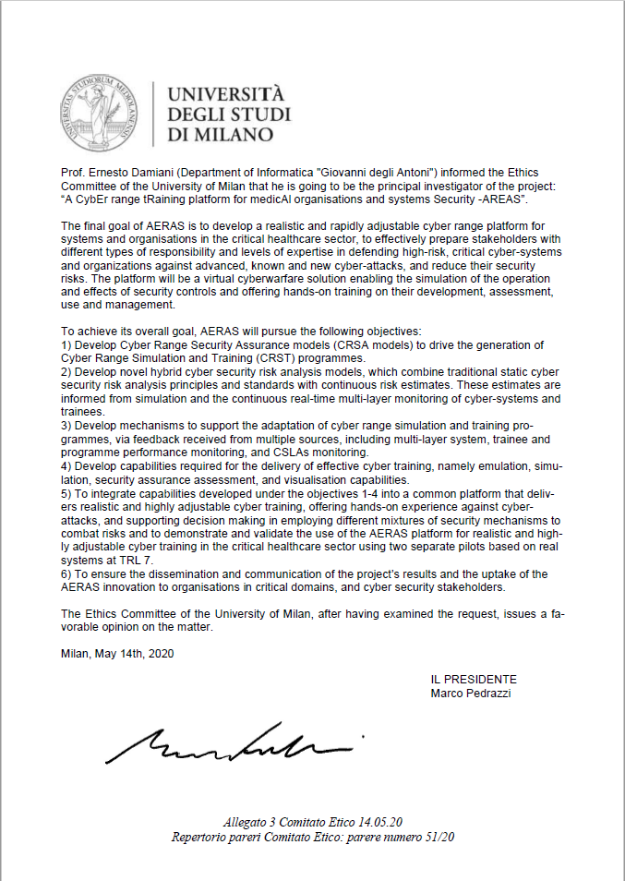

Figure : Ethics Committee opinion.

# **AERAS Protocol**

The following protocol has been presented to the Ethics Committee to present the objectives of the project and the possible risks deriving from the human involvement.

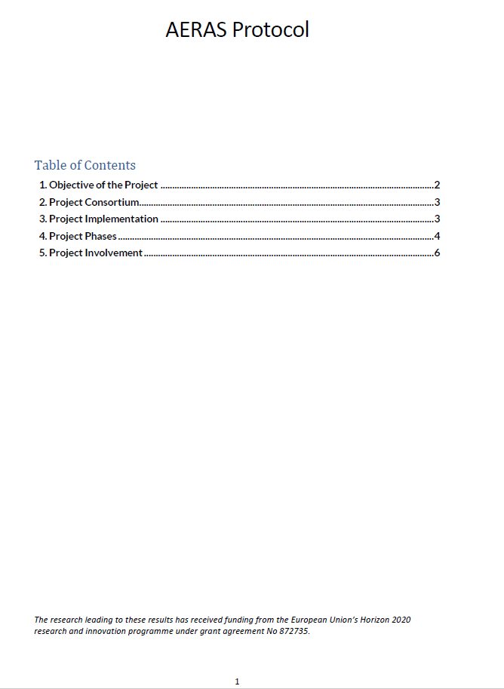

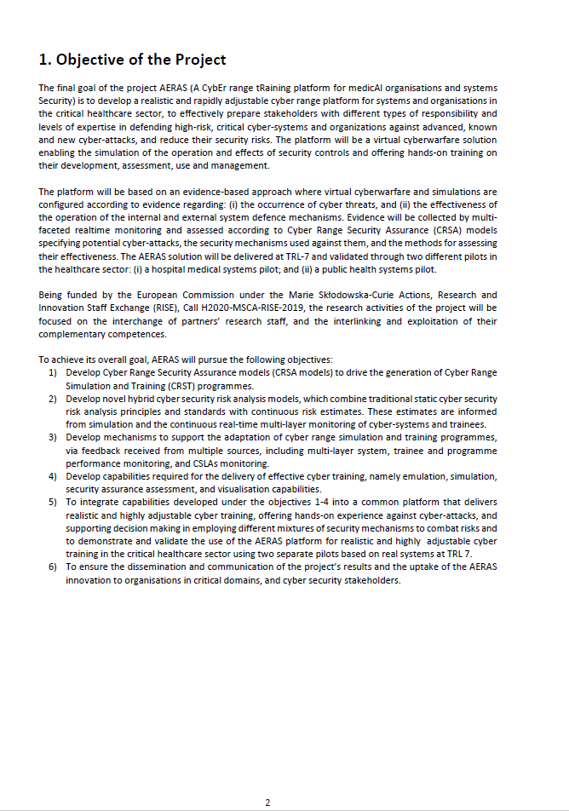

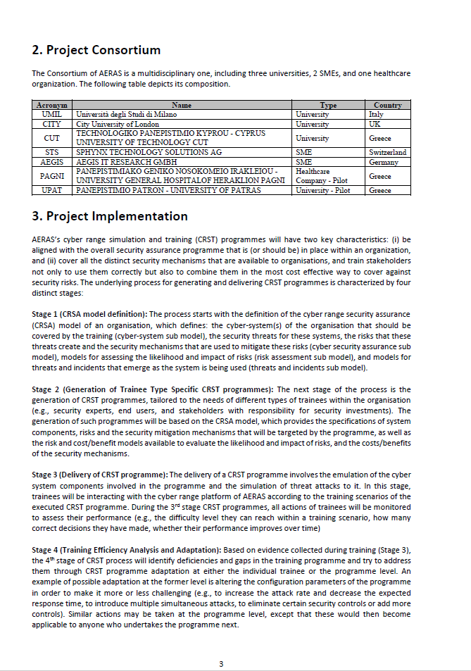

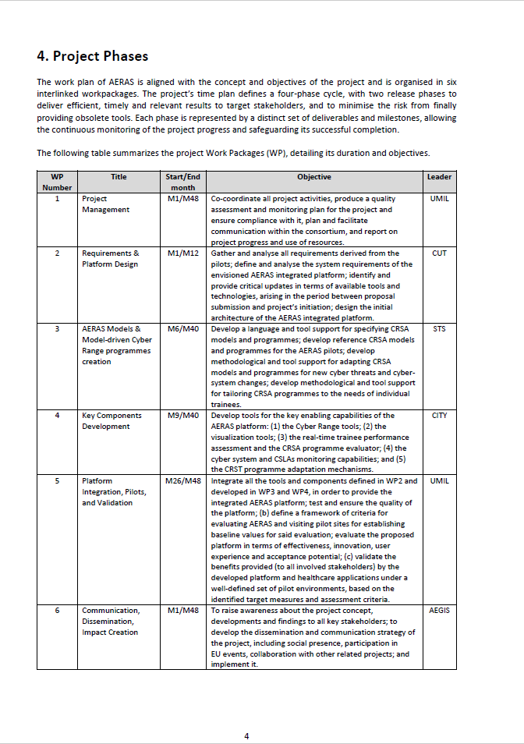

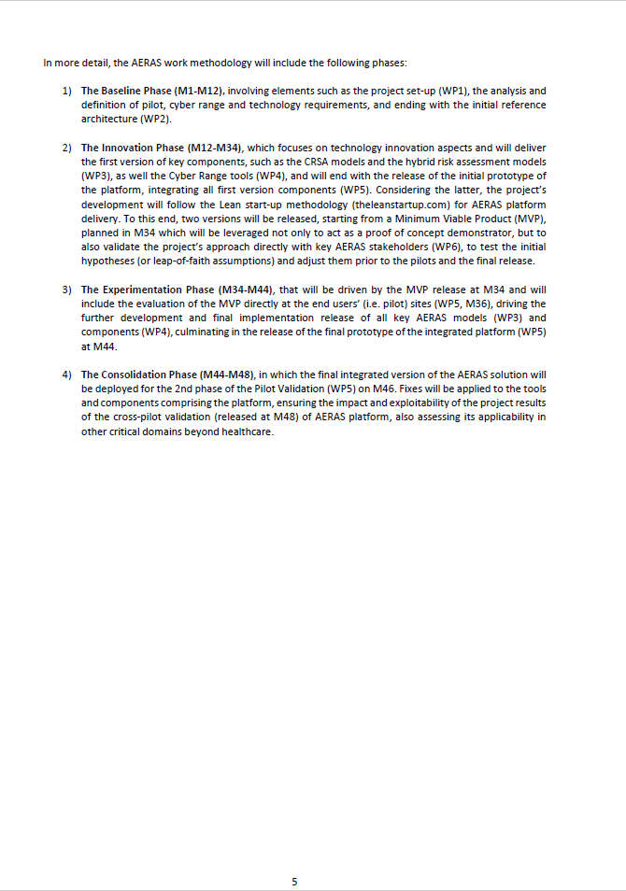

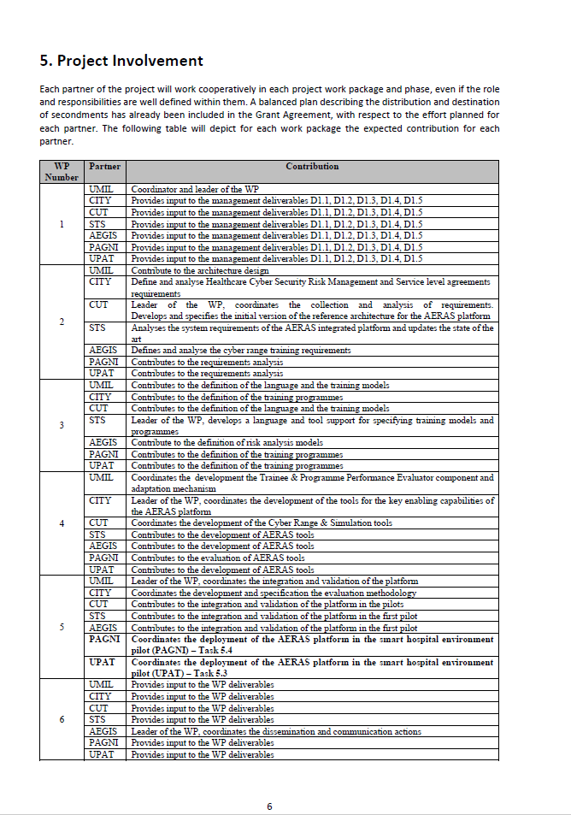

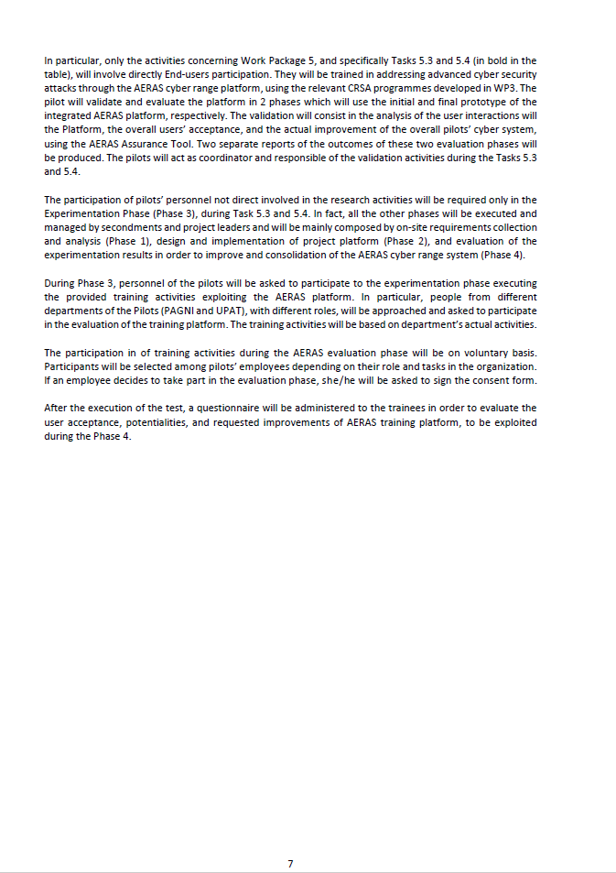

# **Conclusions**

In this deliverable the results of the AERAS hearing to UMIL’s Ethics Committee are presented. During the hearing, the Project Coordinator presented AERAS aims and discussed the possible privacy risks related to the collection and management of personal data and of performance data during the evaluation process of AERAS participants.

The Ethics Committee expressed a favourable opinion about the project’s management of such risks, suggesting only a few adjustments to the project’s Information Sheet, which have been promptly implemented.

# **References**

1. Università degli Studi di Milano. Ethics Committee Regulation (in Italian). Available online: <https://www.unimi.it/sites/default/files/regolamenti/Regolamento%20Comitato%20Etico.pdf>, 2020
2. Università degli Studi di Milano. Code of Ethics and for Research Integrity. Available online: <https://www.unimi.it/sites/default/files/2019-07/Code%20of%20Ethics%20and%20for%20Research%20Integrity%20%28EN%29.pdf>, 2020

# **Appendix A: Official Committee opinion request**

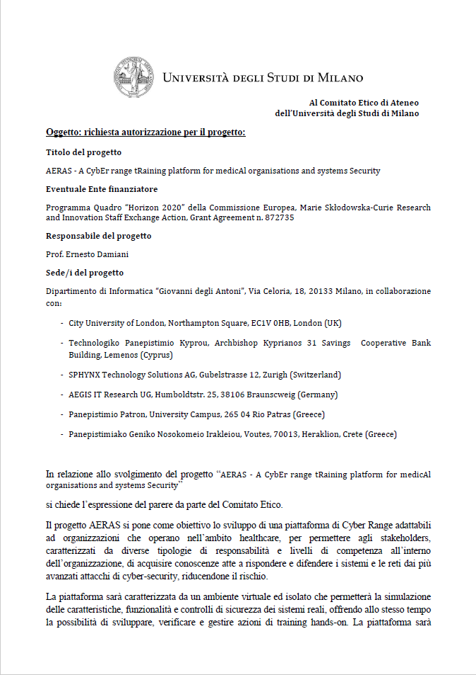

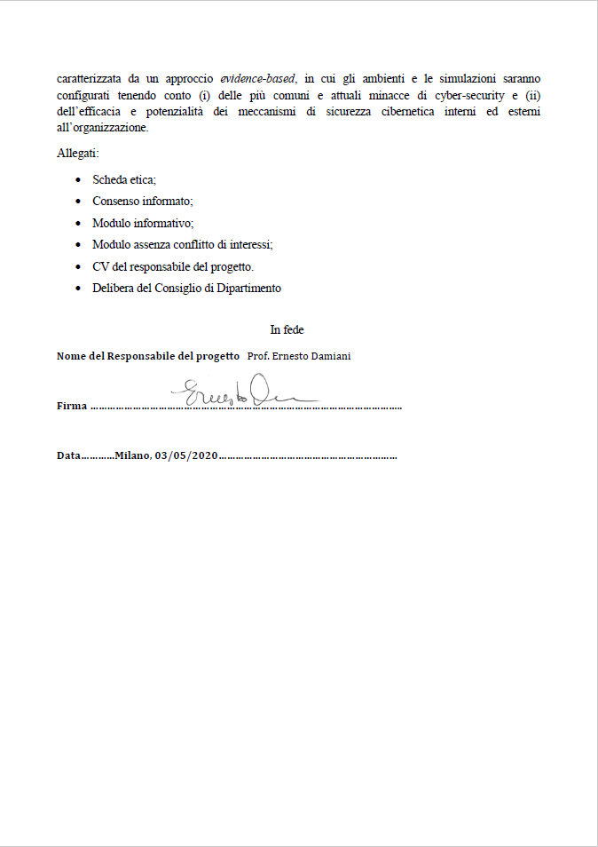

# **Appendix B: Ethical form**

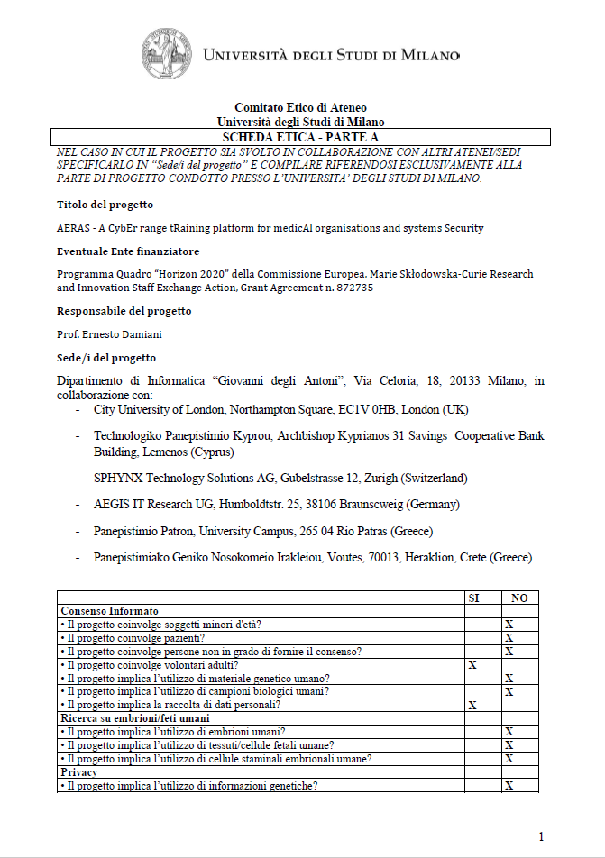

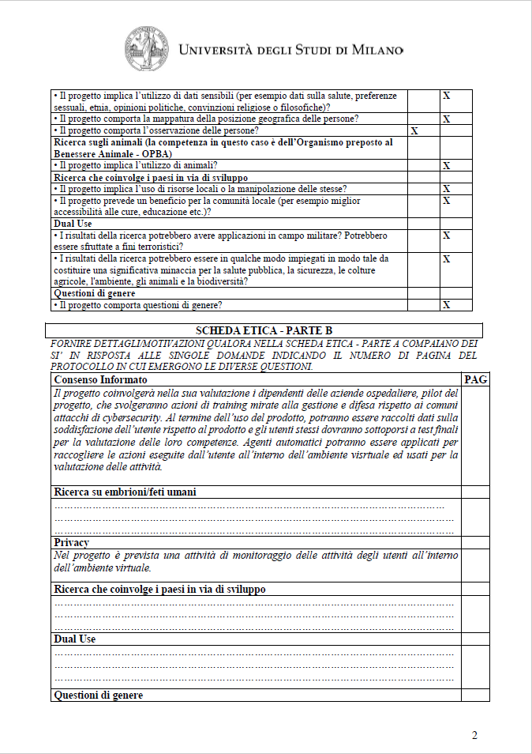

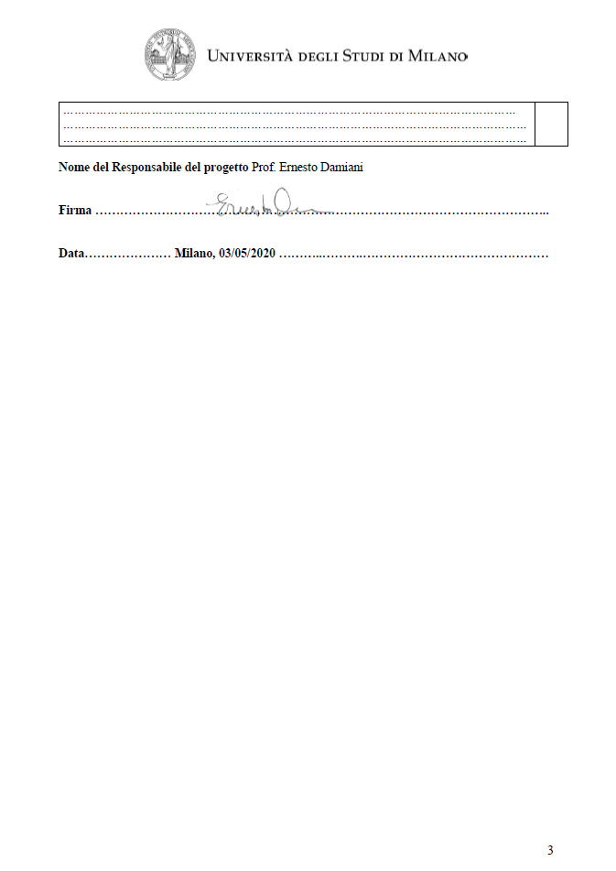

# **Appendix C: Coordinator’s conflict of interest absence form**

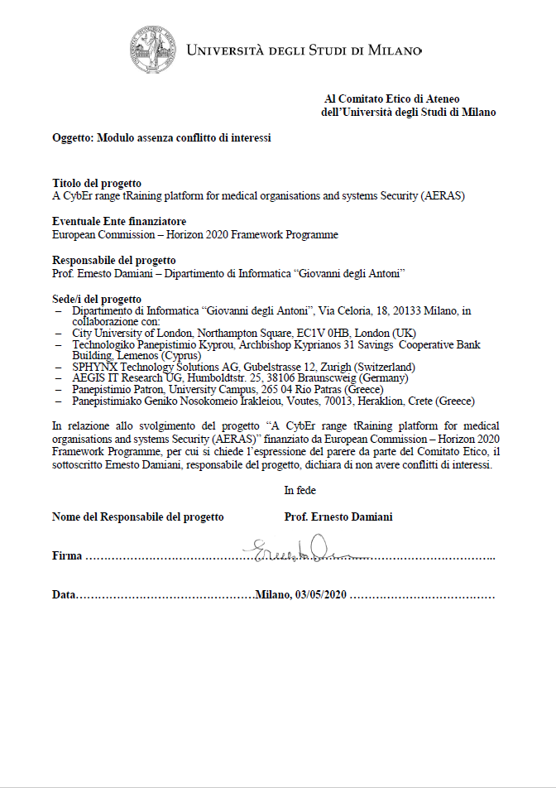

# **Appendix D: Excerpt of the Dep. Of Informatics Council meeting**

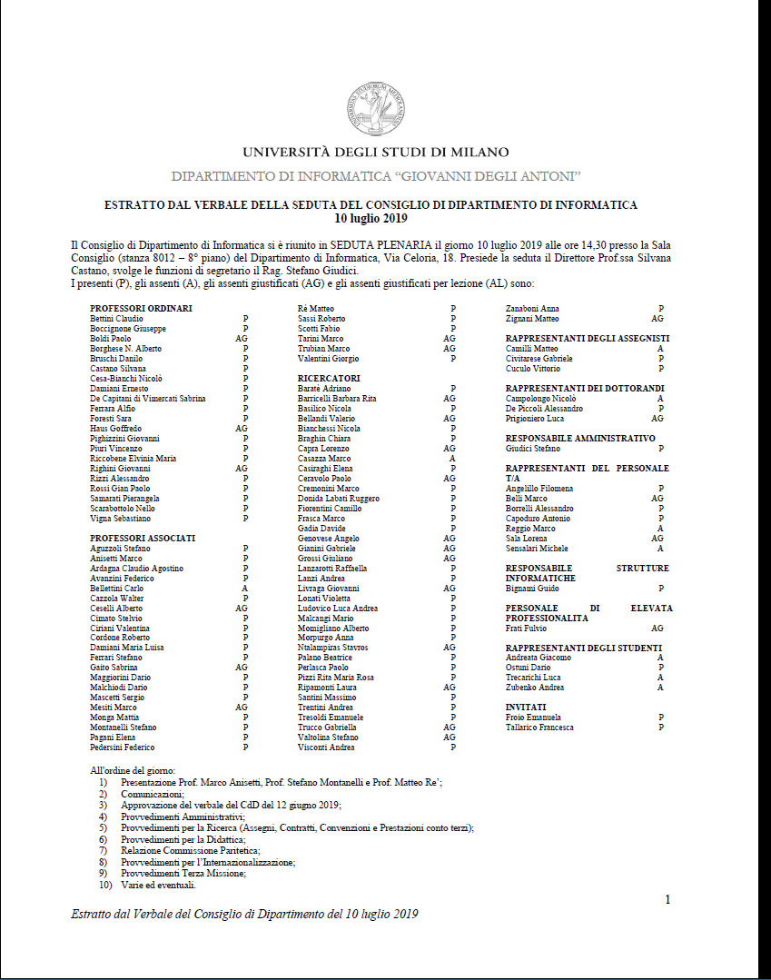

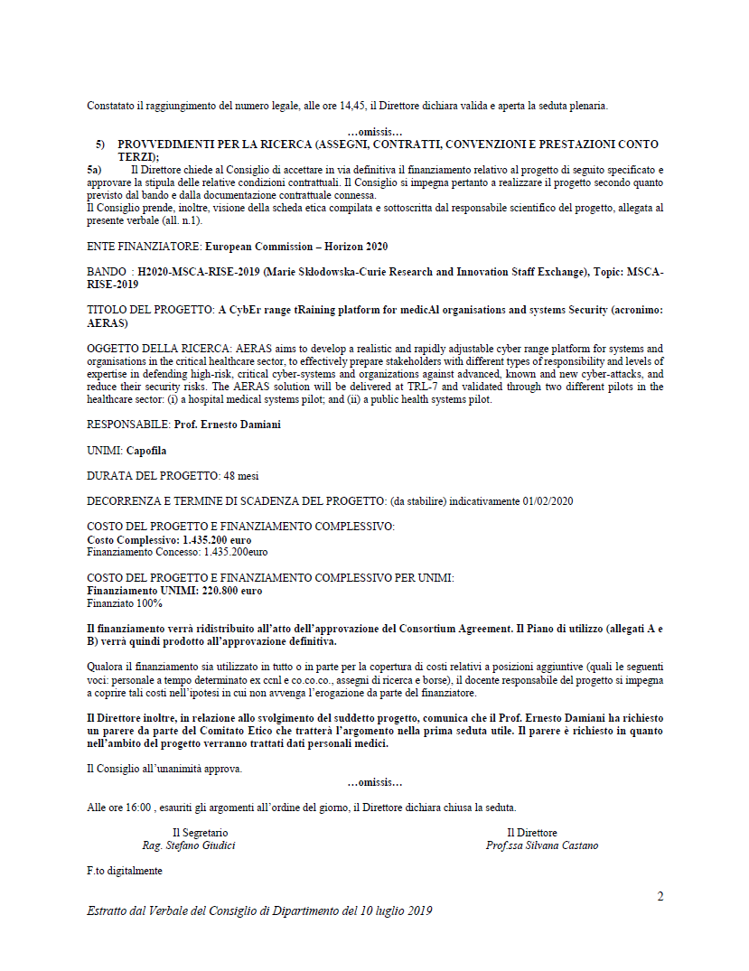

1. † *The research leading to these results has received funding from the European Union’s Horizon 2020 research and innovation programme under grant agreement No 872735.*
2. <https://work.unimi.it/chiedove/cv/ernesto_damiani.pdf>